**Curriculuw Vitar**

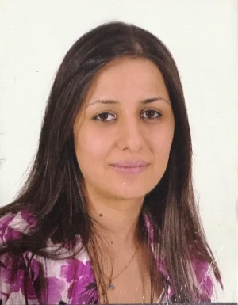

**Name :**  Ekram Rumayth Wadeea

**Data of Birth :** 29/8/1987

**Address :** Duhok – Masike 1 & Mosul – Al arabe

**Contact No. :** 07502371292

**Mail ID :**  [ekram.rometh@gmail.com](mailto:ekram.rometh@gmail.com)

**Languages Known :** Arabic – Assyrian

**Experience Profile :**

* Worked at Young Missionaries Organization at Erbil Kurdistan Region.
* Worked as volun teer with Samaritan's purse (s.p.i.r) for 2 month in August & September as team member in emergency team for disttributing the goods for IDP .
* Signed a contract with the UNICEF project as a team leader when I was work with T.A.D .
* I have a Certificate of Completion ( Child Protection Case Managements ) from ( OCHA & ACTED ) :

1. Case managements principles .
2. Data protection protocols .
3. Case managements process .
4. Basis of case managements .

* I have a Certificate of appreciation for successful participation in Psychological First Aid Training from ( Save The Children ):

1. A Training in PFA .
2. Covering the theory of the PFA approach .
3. Dealing with traumatic responses .

* I have a Certificate of appreciation in training course entitled ( the Art of Leadership ) from ( Alibda,a Organization for Youth Development ( A.O.Y.D ) & HAVRANG Organization for Coexistence and korbenda sereim ya qutabiyan ) .
* I have a Certificate of appreciation in Writing projects and obtaining funding from ( U.N.D.P & Department of NGOs ) .
* I have a Certificate of Completion ( Case Management in emergency and GBV) from (OCHA & ACTED ) :

1. Case management in emergency.
2. Type of cases.
3. Case workers role.
4. Gender base violence definition
5. GBV plan.

* I have a Certificate of Completion ( Communicating With Communities CWC) from ( UNHCR & QANDIL)
* I have a Certificate of Completion (Child rights moniuoring and reporting ) from (UNICEF)
* I have a Certificate of Completion ( Child Protection Training ) from ( Triangle) :

1. Child protection.
2. Case management.
3. Psychological first Aid

* I have a Certificate of Completion ( Child Protection and Case Management Training ) from ( UNHCR & Triangle ) .
* I have a Certificate of Completion ( Syrian & Iraqi Partner Collaboration Meeting ) from ( ICAN ) in beirut – Lebanon.

**She worked as a project manager for Vina Zaruka for family and child care and education for 4 months**

1. Fast and accuracy in work .

2. Experience in working on Microsoft Office .

3. Computer skills .